**YOUR GROUP’S DATASET**

A Fairer Start: Early Years Foundation Stage Profile

Your dataset is a snapshot from the 2022 Early Years Foundation Stage Profile results. This snapshot shows the percent of children assessed to be reaching a Good Level of Development in each region in England broken down by those eligible for Free School Meals and those not eligible. Free School Meal eligibility can be considered an indicator of children’s disadvantage.

Take a few minutes to read about your dataset [here](https://explore-education-statistics.service.gov.uk/find-statistics/early-years-foundation-stage-profile-results).

|  |  |  |
| --- | --- | --- |
| Region | Percent of Children **known to be eligible for** Free School Meals Reaching a Good Level of Development | Percent of Children **not** **known to be eligible for** Free School Meals Reaching a Good Level of Development |
| North East | 48.7 % | 69.5 % |
| North West | 46.2 % | 65.8 % |
| Yorkshire and The Humber | 48.7 % | 68.4 % |
| East Midlands | 48.7 % | 68 % |
| West Midlands | 50.5 % | 67.5 % |
| East of England | 46.5 % | 67.8 % |
| South East | 47.4 % | 70.9 % |
| South West | 46.1 % | 69.8 % |
| Inner London | 57.9 % | 70.5 % |
| Outer London | 54.7 % | 70.2 % |

**YOUR GROUP’S DATASET**

A Fairer Start: Health Visitor Service Delivery Metrics

Your dataset is a summary of the Health Service Delivery Metrics for various health visits throughout a child’s early years. The data here shows the summary for all of England of the percent of eligible children receiving each of the early years health visits from 2018 - the latest annual release.

Take a few minutes to read about your dataset [here](https://www.gov.uk/government/statistics/health-visitor-service-delivery-metrics-experimental-statistics-annual-data-2021-to-2022).

|  |  |  |  |  |
| --- | --- | --- | --- | --- |
|  | **Births that receive a face to face New Birth Visit (NBV) within 14 days by a Health Visitor** | **Infants who received a 6-8 week review by the time they were 8 weeks** | **Children who received a 12 month review by the time they turned 12 months** | **Children who received a 2-2½ year review** |
| **2018 - 2019** | 89% | 85% | 77% | 78% |
| **2019 - 2020** | 87% | 85% | 77% | 79% |
| **2020 - 2021** | 88% | 80% | 66% | 72% |
| **2021 - 2022** | 83% | 82% | 72% | 74% |

**YOUR GROUP’S DATASET**

A Healthy Life: DETAILS OF PURCHASES FOR HOUSEHOLD SUPPLIES

Your dataset is a snapshot from the GOV.UK Family Food Datasets 2018/19 Expenditure on household and eating out food & drink by Government Office Region and Country results. This dataset combines information from the ‘purchases’ and ‘expenditure’ datasets broken down by Nation (England, Wales, and Scotland). The ‘purchases’ dataset gives the average quantity of food and drink purchased per person per week for each food category. The ‘expenditure’ dataset gives the average amount spent in pence per person per week on each food category.

Take a few minutes to read about your dataset [here](https://www.gov.uk/government/statistics/family-food-201819/family-food-201819).

|  |  |  |  |  |  |  |
| --- | --- | --- | --- | --- | --- | --- |
| Food Category | England | | Wales | | Scotland | |
| Expenditure | Quantity Purchased | Expenditure | Quantity Purchased | Expenditure | Quantity Purchased |
| Average pence per person per week | Averages per person per week | Average pence per person per week | Averages per person per week | Average pence per person per week | Averages per person per week |
| Milk and milk products excluding cheese | ​​190p | 1,803 ml | 191p | 2,197 ml | 181p | 1,959 ml |
| Cheese | 91p | 125 g | 81p | 115 g | 92p | 127 g |
| Carcase meat | 126p | 166 g | 139p | 194 g | 132p | 171 g |
| Non-carcase meat and meat products | 491p | 773 g | 559p | 998 g | 554p | 852 g |
| Fish | 153p | 147 g | 140p | 147 g | 136p | 137 g |
| Eggs | 31p | 2 | 34p | 2 | 33p | 2 |
| Fats | 58p | 163 g | 58p | 151 g | 69p | 146 g |
| Sugar and preserves | 19p | 96 g | 16p | 89 g | 13p | 69 g |
| Fresh and processed fruit and vegetables, including potatoes | 663p | 2,881 g | 632p | 3,033 g | 603p | 2,650 g |
| Bread | 116p | 502 g | 115p | 533 g | 138p | 672 g |
| Flour | 5p | 50 g | 2p | 39 g | 2p | 35 g |
| Cakes, buns and pastries | 78p | 149 g | 84p | 178 g | 68p | 143 g |
| Biscuits and crispbreads | 77p | 157g | 63p | 153 g | 87p | 174 g |
| Cereals and cereal products | 257p | 590 g | 255p | 646 g | 275p | 558 g |
| Beverages | 63p | 52 g | 52p | 46 g | 56p | 48 g |
| Soft drinks | 111p | 1,623 ml | 84p | 1,609 ml | 131p | 1,785 ml |
| Confectionery | 114p | 132 g | 137p | 168 g | 128p | 157 g |
| Alcoholic drinks | 380p | 719 ml | 370p | 706 ml | 406p | 659 ml |

**YOUR GROUP’S DATASET**

A Healthy Life: Energy and nutrient intakes derived from household food & drink

Your dataset is a snapshot from GOV.UK Family Food Datasets 2018/19 Energy and nutrient intakes derived from household food & drink by government office region & country results. This snapshot shows the average intake of each nutritional category as a percentage of the estimated average nutritional requirements per person per day broken down by Nation (England, Wales, and Scotland).

Take a few minutes to read about your dataset [here](https://www.gov.uk/government/statistics/family-food-201819/family-food-201819#purchases).

|  |  |  |  |
| --- | --- | --- | --- |
| Description | Average intake as a percentage of estimated average nutritional requirements per person per day | | |
| England | Wales | Scotland |
| Energy | 92% | 101% | 95% |
| Energy excluding alcohol | 90% | 98% | 92% |
| Protein | 144% | 168% | 156% |
| Calcium | 123% | 139% | 135% |
| Iron | 101% | 108% | 99% |
| Zinc | 97% | 112% | 104% |
| Magnesium | 98% | 106% | 98% |
| Sodium | 156% | 174% | 175% |
| Potassium | 87% | 97% | 89% |
| Thiamin | 179% | 203% | 177% |
| Riboflavin | 150% | 177% | 154% |
| Vitamin A (retinol equivalent) | 220% | 253% | 228% |
| Vitamin B6 | 142% | 162% | 143% |
| Vitamin B12 | 381% | 457% | 415% |
| Folate | 126% | 137% | 122% |
| Vitamin C | 190% | 199% | 176% |
| Vitamin A (retinol equivalent) | 128% | 144% | 127% |

**YOUR GROUP’S DATASET**

A Sustainable Future: Home Retrofits

Your dataset shows the costs, energy bill savings, reductions in carbon emissions and levels of disruption for a variety of home retrofits. The values are for an average 3-bed semi-detached UK house that is currently heated by a gas boiler, and prices are correct as of October 2022.

The source is the [Energy Saving Trust’s home heating advice page](https://energysavingtrust.org.uk/energy-at-home/heating-your-home/). Visit this page if you’d like to read more about these different measures. **Please note: this dataset was compiled from a variety of sources and is meant for illustrative purposes only and the statistics have not been validated.**

|  |  |  |  |  |  |
| --- | --- | --- | --- | --- | --- |
| Measure | Typical capital cost (£) | Energy bill savings (£/year) | CO2 savings (kgCO2/yr) | CO2 savings (kgCO2/yr) per £1000 capital cost | Level of disruption |
| Loft insulation | 640 | 355 | 610 | 950 | Low |
| Floor insulation | 2,250 | 110 | 190 | 80 | High |
| Double glazing (windows & doors) | 7,500 | 235 | 405 | 50 | Medium |
| Draught proofing | 225 | 60 | 100 | 440 | Low |
| External wall insulation* | 12,000 | 540 | 910 | 80 | High |
| Cavity wall insulation* | 1,000 | 395 | 670 | 670 | Medium |
| Air source heat pump** | 12,500 | 350 | 2,300 | 180 | Medium |

*Cavity wall insulation can only be applied if the property has cavity walls. If it has solid walls then solid (internal or external) wall insulation must be applied.

**CO2 savings assume Oct 2022 carbon intensity of electricity grid. If 100% renewable electricity generation is achieved, CO2 savings would be 3200 kgCO2/yr (260 kgCO2/yr per £1000 capital cost).

**YOUR GROUP’S DATASET**

A Sustainable Future: Carbon Emissions

This dataset shows the carbon emissions resulting from various activities, including the operation of various household appliances. It is inspired by Nesta’s [carbon calculator](https://www.nesta.org.uk/project-updates/how-much-your-gas-boiler-costing-earth).

Values have been gathered from various sources including [[1]](https://tomchurch.co.uk/how-to-calculate-your-carbon-footprint-how-bad-are-bananas/), [[2]](https://www.bbc.com/future/article/20200310-sustainable-fashion-how-to-buy-clothes-good-for-the-climate), [[3]](https://ourworldindata.org/co2/country/united-kingdom#per-capita-how-much-co2-does-the-average-person-emit), [[4]](https://bulb.co.uk/carbon-tracker/), [[5]](https://www.ofgem.gov.uk/information-consumers/energy-advice-households/average-gas-and-electricity-use-explained) and [[6]](https://www.carbonfootprint.com/energyconsumption.html). It can be difficult to find reliable emissions data, but feel free to look online to find values for any other activities or products you can think of. You don’t need to visualise everything below, but home heating (bolded) is most relevant to the mission. **Please note: this dataset was compiled from a variety of sources and is meant for illustrative purposes only and the statistics have not been validated.**

|  |  |
| --- | --- |
| Activity / item | CO2 emissions (kg) |
| Sending a text | 0.000014 |
| 1 hour LED bulb | 0.0018 |
| 1 hour Netflix | 0.056 |
| Pint of beer | 0.5 |
| Loaf of bread | 1 |
| 4-ounce beef steak | 2 |
| 10 minute shower | 2 |
| Amount absorbed by one tree per year | 2 |
| Polyester shirt | 5.5 |
| Pair of jeans | 33 |
| 1 year gas oven use | 38 |
| 1 year microwave use | 39 |
| 1 year washing machine use | 51 |
| 1 year dishwasher use | 51 |
| 1 year gas hob use | 71 |
| 1 year kettle use | 73 |
| 1 year fridge-freezer use | 116 |
| 1 year tumble dryer use | 159 |
| Amount saved by doing 1 year's worth of recycling | 160 |
| Driving from Land's End to John O'Groats | 170 |
| Flying from London to New York | 310 |
| A hectare of deforestation | 500 |
| 1 year of household electricity use | 560 |
| Driving 10,000 km (approximate average distance driven by UK drivers per year) | 1,200 |
| **1 year home heating with gas (space and hot water)** | **2,700** |
| Average UK emissions per capita per year | 5,200 |

**PERSONA CARDS**

Please select one of the following personas to build for:





**SCENARIO CARDS**

Please select one of the following scenarios that your persona will be interacting with your physicalisation:

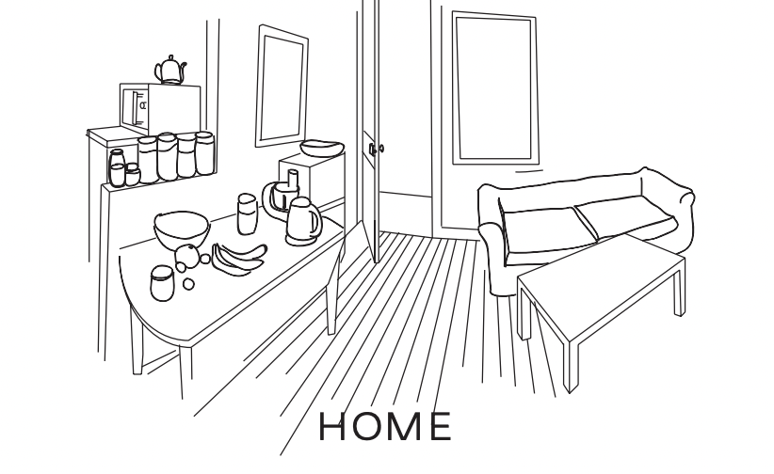

**ACTIVITY CARDS**

Please select one of the following activities that your persona will be doing when they interact with your physicalisation:

